Chapter 12, Problem 72.

If wattmeters W₁ and W₂ are properly connected respectively between lines a and b and lines b and c to measure the power absorbed by the delta-connected load in Fig. 12.44, predict their readings.

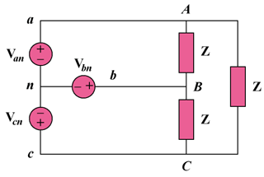

Figure 12.44
For Prob. 12.72.

